Support and Charity Foundation Mamų unija (Mothers’ Union)  Company code 302288579  VAT code: 100009837618  Prašiškių g. 47 , Vilnius region,  Swedbank, AB  Bank code 73000  SWIFT code HABALT22  Account No LT 77 7300 0101 4079 5625  www.mamuunija.lt | 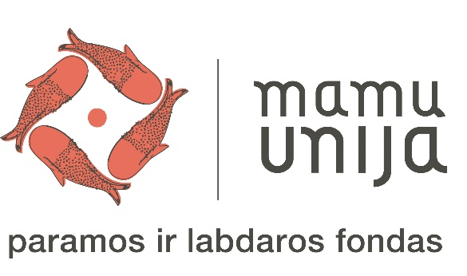

Report on the funds collected during the television project
Gyventi gera

On 22 February 2020, for the first time ever, the Support and Charity Foundation Mamų unija, in collaboration with LRT (the national public broadcasting company), organised a charity concert Gyventi gera. Famous Lithuanian performers donated their performances together with the children who are ill and those who already recovered. The concert was a way to raise public awareness of a complicated cancer diagnosis, inform of the problems and challenges that children with cancer and their families are struggling with every day. The aim of the project was to collect the remaining funds for the implementation of the Mamų unija’s project Family Home.

LRT provided project dissemination and publicity services free of charge.

Total funds collected during the concert Gyventi gera: EUR 141 167.36

In the Mamų unija’s Family Home this amount was allocated to the installation and finishing works of:

Swimming pool technological equipment installation, start-up and maintenance. | EUR 18 618.49
Floor boards and their installation | EUR 9 176.10
Aluminium profile doors | EUR 1 615.00
Outdoor lighting installation works | EUR 11 870.42
Electricity installation works, including supply of materials, construction, mounting and painting works | EUR 17 288.40
Outdoor irrigation systems, system installation works | EUR 12 578.22
50 ares of lawn fitting-out works around the building, soil, soil preparation, sowing works | EUR 10 423.55
Environmental improvement works (tile laying, plastic honeycomb cover (for ambulances and fire trucks), installation of side structures) | EUR 17 584.52
Water supply, sewage and heating installation works | EUR 10 076.00
Fence installation around 1 ha perimeter | EUR 10 859.12
Ceiling installation in the building, revision-type doors for the completion of installation works | EUR 6 613.56
Window sealing materials and materials for the completion of installation works | EUR 5 164.85
Kitchen, closet and TV-zone block furniture in the rooms | EUR 10 000.00
Total amount: | EUR 141 868.23

Mamų unija (the Mothers’ Union) is the support and charity foundation that has been taking care of every child in Lithuania suffering from an oncological illness for 11 years.

The mission of the foundation is to ensure comprehensive assistance to each and every child suffering from an oncological illness and for his or her family, to make every effort to change the society’s attitude toward children with cancer or disability.

Around 100 children fall ill with cancer in Lithuania every year. 80–90 percent of those children recover. The process of oncological disease treatment is long and complicated and it may last from 6 months to several years or even longer. When a child is affected by an oncological disease, his or her family faces a number of complex challenges that neither treatment institutions nor the Government are able to solve fully.

Mamų unija provides assistance and focuses its activity on the following aspects:

- Hospital activities: the foundation helps to acquire necessary treatment equipment, repair rooms, kitchens, improves micro-climate in the children’s oncological hospital divisions (purchases equipment, beds, furniture, toys, computer equipment, bed linen, and kitchenware), purchases medication, organises educational classes, parties and events.

- Family assistance: the foundation provides financial assistance, purchases non-compensated medicines, food, clothing, nursing and hygiene products (diapers, single use covers, wipes, body wash, creams, band-aids), covers travel expenses to and from hospital, provides informational assistance, supports child’s treatment in hospitals abroad, organises children’s camps in Lithuania and abroad, fulfils the children’s dreams, organises birthday parties and other occasions.

Mamų unija FAMILY HOME PROJECT:
The foundation’s long-term experience with the families whose children have cancer showed that the state-provided complex assistance system works only partially and does not ensure that all the needs of the child’s family during the illness are met (such as problems related to emotional, social, educational aspects, problems due to the lack of information or family’s inability to stay together during the child’s illness); neither it provides necessary attention and support to the families who lost their child due to the illness. Therefore, the foundation, having assessed the best time-proven practices of foreign funds, has initiated and started developing the Mother’s Union Family Home project in Lithuania.

The aim of the project is to develop a complex and unified support system for the whole family of a sick child ensuring that psychological, social, informational and spiritual needs are met and families are able to integrate into the social life.

The Family Home is to be built on a land plot of 1 ha. Building area – 2,000 sq. m
Project value – EUR 2.5 mln.

Issue to be solved:
- parents and other family members coming to visit their sick child have no place to stay overnight;
- only one person is allowed to stay with a patient in a hospital room; usually that person is a mother;
- the majority of parents find it difficult and financially burdensome to stay in a hotel or some other type of accommodation.

The Mamų unija project is designed to meet the needs of EVERY ill child and his or her family so that all the attention is focused on treatment and its success

Residential block:
- 11 mini-suites for the families of ill children accommodated to facilitate nursing and family household needs (with kitchenettes, WC (accessible for people with disabilities), closets, etc.). All suites shall have separate exits to private terraces.
- Onco-information centre.
- The building block is expected to have a common sitting area, a dining-room and a kitchen equipped for common household purposes.
- 1 children’s play area.
- Laundry room.
- Administrative premises.

Rehabilitation centre:
- 6 rehabilitation rooms equipped for psychological, spiritual, art, music and light therapies.
- Sports / kinesitherapy room.
- A swimming pool with the highest quality water-cleaning technology and rehabilitation equipment for people with disabilities.
Other household buildings and areas:
- Production facilities.
- Greenhouse for growing herbs and vegetables.
- Berry bushes and garden.

Director Justina Žukauskienė

